AIM:

Write a Python program to get a list of numbers of list and create a list of tuples having first element as the number and second element as the cube of the number.

PROGRAM:

n=int(input())

l=[]

for i in range(n):

a=int(input())

l.append((a,a*a*a))

print(l)

for i in range(0,len(l)):

for j in range(i+1,len(l)):

if(l[j][1]<l[i][1]):

temp=l[i]

l[i]=l[j]

l[j]=temp

print(l)

**OUTPUT:**

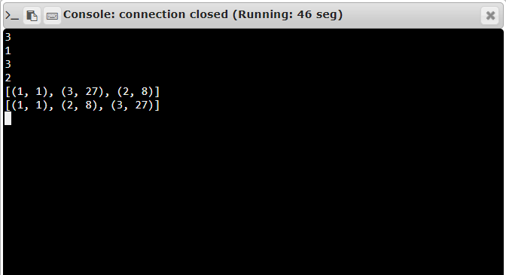

LINK:

<http://103.53.53.18/modd1700=#/vpl/forms/edit.php?id=317&useri>

Result:

***Thus, the program was executed successfully.***